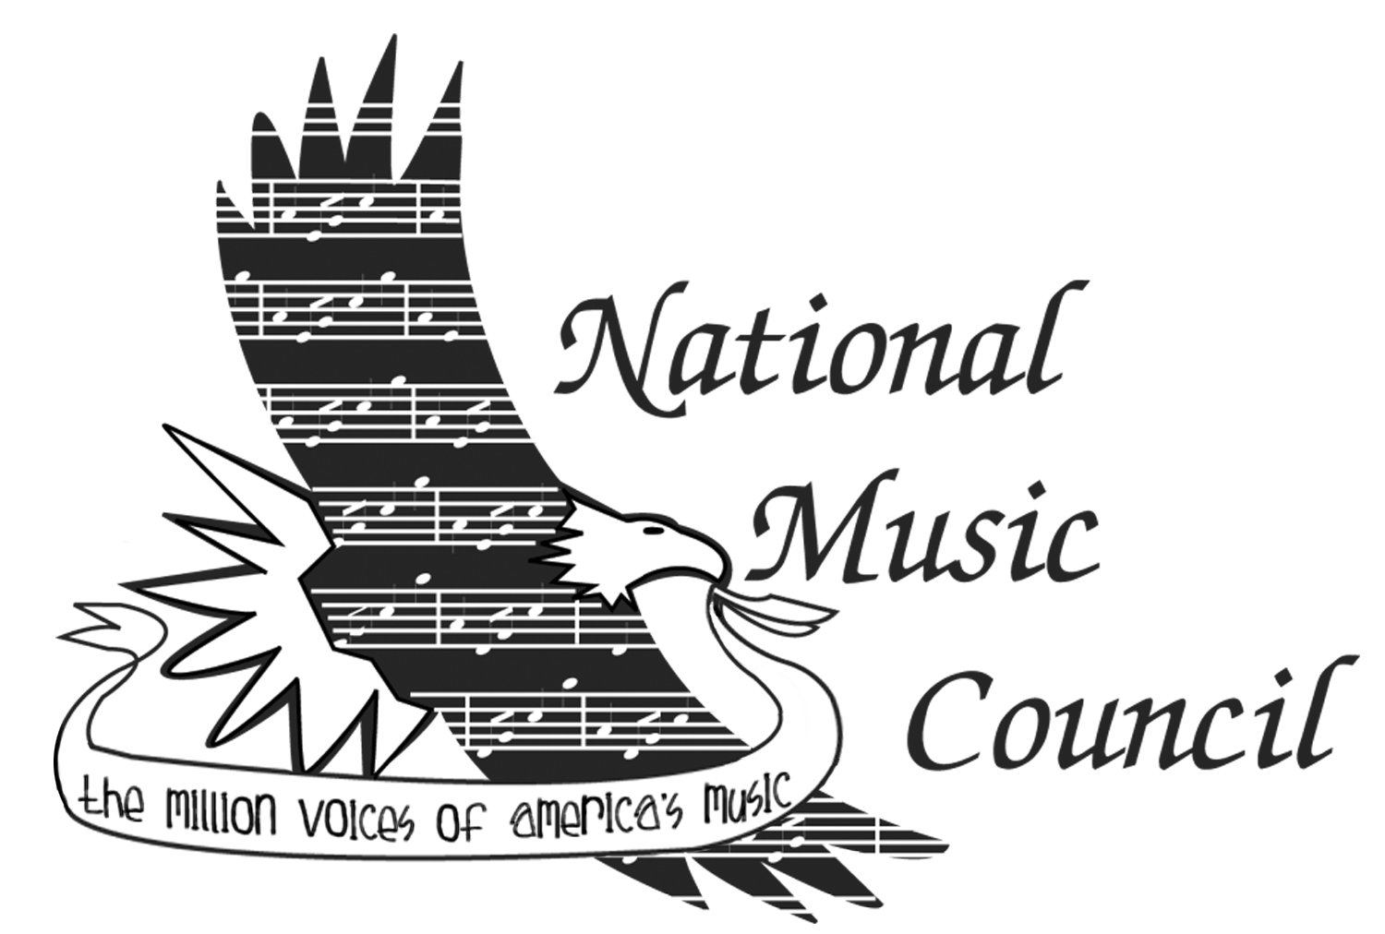Digital Program Ad Reservation
2022 American Eagle Awards

Name:
Company:
Address:
City/State/Zip:

Telephone #:
Email:

The 2022 American Eagle Award Program will be digital. Digital ads will be projected as part of a loop on the event jumbo screens during the 15 minutes prior to the presentation ceremony, as well as posted on the NAMM Event and NMC websites. Please be sure to include a file of your logo as well, which will also be displayed, as sponsors of the event.

Ad Specs

Large ad format: 1080 pixels wide x 1920 pixels tall (9x16 ratio) @ 150dpi.

Small ad format: 1080 pixels wide x 960 pixels tall (9 x 8 ratio) @ 150dpi.

File Format: Flattened JPG or PDF. We can work with almost any file type as long as the resolution will hold up for HD. (600 pixel minimum) Vector based file is best.

Send ad file, logo file, and this form to sandersd@montclair.edu

Please reserve the following ad space in the Digital Program / Journal

___ Large Ad - 1080 pixels wide x 1920 pixels tall (9x16 ratio) @ 150dpi $1,000

___ Small Ad - 1080 pixels wide x 960 pixels tall (9 x 8 ratio) @150dpi $ 500

___ I would like to make a tax-deductible contribution

Please make check payable to National Music Council Total Enclosed: $___________

Mail prior to May 27, 2022, with this card to: National Music Council,
425 Park Street
Montclair, NJ 07043

For more information contact David Sanders at (201) 341-5913 or sandersd@montclair.edu

