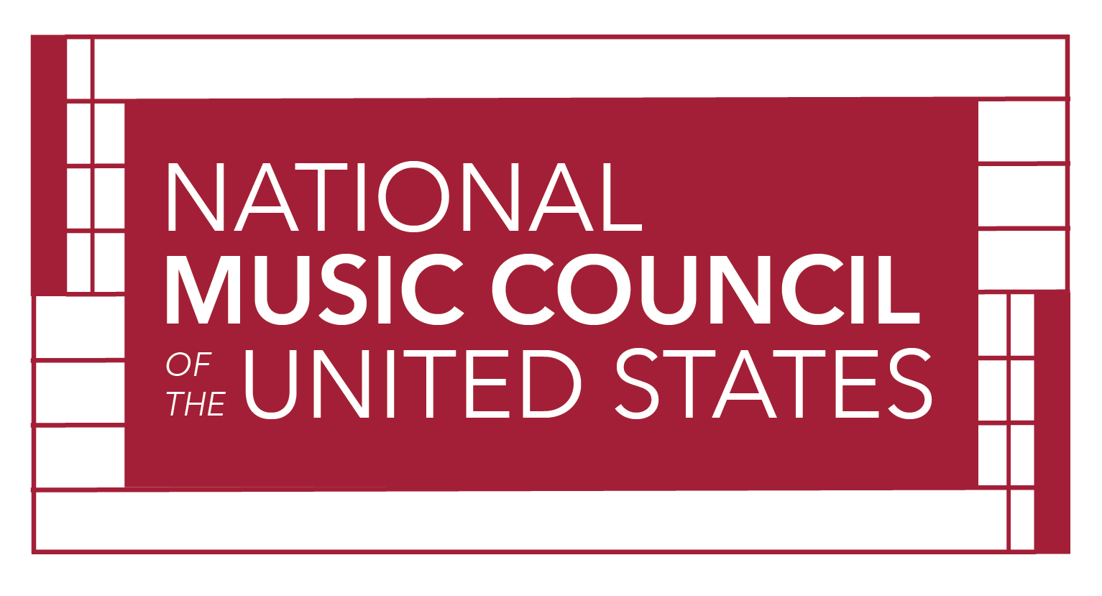
Digital Program Ad Reservation
2024 American Eagle Awards
Name:
Company:
Address:
City/State/Zip:
Telephone #:
Email:

The 2024 American Eagle Award Program will be digital. Digital ads will be accessible at the presentation ceremony via QR Code, as well as posted on the NMC website. Please be sure to include a file of your logo as well, which will be displayed as a co-sponsor of the event.

Ad Specs
Large Ad Format: 9" x 16" with .25 bleed 300dpi 2700 x 4800 pixels
Small Ad Format: 9" x 8" with .25" bleed 300dpi 2700 x 2400 pixels
File Format: Flattened JPG or PDF. We can work with almost any file type as long as the resolution dpi and pixel size are correct.
Send ad file, logo file, and this form to sandersd@montclair.edu

Please reserve the following ad space in the Digital Program / Journal

___ Large Ad - 1080 pixels wide x 1920 pixels tall (9x16 ratio) @ 300dpi $1,000

___ Small Ad - 1080 pixels wide x 960 pixels tall (9 x 8 ratio) @300dpi $ 500

___ I would like to make a tax-deductible contribution

Please make check payable to National Music Council Total Enclosed: $___________

Mail prior to June 1st, 2024, with this card to: National Music Council,
425 Park Street
Montclair, NJ 07043

For more information contact David Sanders at (201) 341-5913 or sandersd@montclair.edu

The American Eagle Awards is a fundraiser for the National Music Council’s Music Education Advocacy & Creator’s Rights Education Programs

